**FEM Lab B**

Yue Jiao

Here in this lab, the following equation is going to be solved.

$$-∇⋅\left(α\left(x\right)∇u\left(x\right)\right)=f\left(x\right), x∈Ω$$

With $x=(x_{1},x_{2})$ and $Ω=\left[0,1\right]×\left[0,1\right]$ and the homogeneous Dirichlet boundary conditions:

$$u\left(x\right)=0, ∀x∈∂Ω=Γ$$

1. The weak formulation of this problem should be to find $u∈V=\{v:v=0 on Γ and \int_{Ω}{\left(v^{2}+{\left(∇v\right)}^{2}\right)dx<∞}\}$ such that:

$$\int_{Ω}{fvdx}=\int_{Ω}{-∇⋅\left(α\left(x\right)∇u\left(x\right)\right)v}=\int_{Ω}{α∇u∇vdx}-{\left[αv∇u\right]}^{Ω}=\left\{v=0 on Γ\right\}=\int_{Ω}{α∇u∇vdx}, ∀v∈V$$

So, the FEM method is to find $u∈V_{h}$, such that

$$\int_{Ω}{α∇u∇vdx}=\int_{Ω}{fvdx}, ∀v∈V_{h}$$

$$where V_{h}=\left\{set continuous piecewise linear functions on Ω and is 0 on Γ\right\}$$

1. To compute the FEM, we discretize the domain $Ω$ into small $2{(N+1)}^{2}$ small triangles. It is done by discretize each side of $Ω$ into $(N+1)$ equal sized pieces so it forms ${(N+1)}^{2}$ equally sized squares. Then each square is divided into $2$ triangles by connecting the upper-left corner and the lower-right corner. Thus, we shall get $2{(N+1)}^{2}$ triangles. Thus $2N^{2}$ inner nodes. We label these inner nodes from the lower-left corner toward right from $1$ to $N$ and continuous next row above it from $2$ to $2N$ until $N^{2}$. The lower-left part of the discretization is showed below:

$$⋮$$

$$4+N$$

$$3+N$$

$$2+N$$

$$1+N$$

II

III

I

$$4$$

3

2

1

$…$

VI

IV

V

Then, we choose that $v=\sum_{1}^{2N^{2}}{v\left(N_{j}\right)ϕ_{i}(x)}$. Here $N_{j}$ is the node $j$ on the discretization. $ϕ_{i}(x)$ is the hat function $ϕ_{i}\left(N_{i}\right)=\left\{\begin{aligned}1, i=j \\ 0, i≠j\end{aligned}\right.$. Since we are using the same discretization as we did in problem set A, we can use the same basis function as well.

$$ϕ_{ij}\left(x,y\right)=\left\{\begin{aligned}1-\frac{x_{1}-{x_{1}}_{i}}{h}-\frac{x_{2}-{x_{2}}_{i}}{h}, \left(x_{1},x_{2}\right)∈I \\ 1-\frac{x_{2}-{x_{2}}_{i}}{h}, \left(x_{1},x_{2}\right)∈II \\ 1-\frac{{x_{1}}_{i}-x_{1}}{h}, \left(x_{1},x_{2}\right)∈III \\ 1-\frac{{x_{1}}_{i}-x_{1}}{h}-\frac{{x_{2}}_{i}-x_{2}}{h}, \left(x_{1},x_{2}\right)∈IV \\ 1-\frac{{x_{2}}_{i}-x_{2}}{h}, \left(x_{1},x_{2}\right)∈V \\ 1-\frac{x_{1}-{x_{1}}_{i}}{h}, \left(x_{1},x_{2}\right)∈IV \\ 0, else\end{aligned}\right. ⇒ϕ_{i}=\sum_{j}{ϕ_{ij}}$$

From this, we can get the following stiffness matrix $A=(a_{ij})$ where:

$$a_{ij}=\int_{Ω}{αϕ_{i}^{'}ϕ_{j}^{'}}$$

If $α=1$, we can get the following values:

$$a_{ij}=\left\{\begin{aligned}-1, j=i-N \\ -1, j=i-1 \\ 4, j=i \\ -1, j=i+1 \\ -1, j=i+N\end{aligned}\right.$$

The load vector $b=(b_{i})$ can also be calculated:

$$b_{i}=\sum_{j}^{2n^{2}}{\int_{I,II,III,IV,V,VI}{fϕ_{ij}dxdy}}$$

So, we shall have the FEM equation system:

$$Aξ=b$$

Since the index $i$ goes from $1$ to $N^{2}$, $A$ is a $N^{2}×N^{2}$ matrix and $b$ is a $1×N^{2}$ vector. The vector $ξ$ describe the solution of the entire range in a vector form. To compute the integration in the $b$ vector, the $2D$ gaussian $3$ points integration is used because of its fair good accuracy.

1. Here we shall use the FEM above to compute the equation when $α=1$ and $f\left(x\right)=40π^{2}\sin\left(2πx_{1}\right)\sin{(4πx_{2})}$. The results are showed below in two directions.

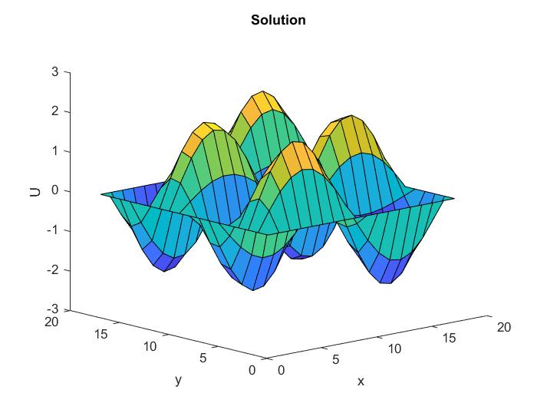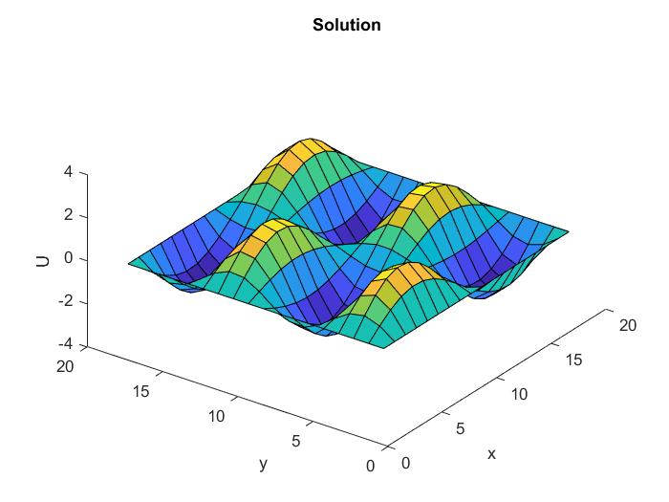

Since we know the exact answer to the equation, the $L_{2}$-norm of the error can be calculated by comparing the analytical result and the numerical result. The errors are showed below and we can see the FEM have a second order convergence in average.

|  |  |  |  |
| --- | --- | --- | --- |
| Step size | $$2^{-2}$$ | $$2^{-3}$$ | $$2^{-4}$$ |
| Error | $$0.6467$$ | $$0.2492$$ | $$0.0432$$ |

1. In this problem, we shall change the boundary condition on edges $x_{1}=0$ and $x_{1}=1$ from Dirichlet BC to Neumann BC:

$$\frac{∂u}{∂n}=∇u⋅n=0$$

Beside this, the force function $f$ is changed to $f=5π^{2}\cos\left(πx_{1}\right)\sin{(2πx_{2})}$ which corresponds to the exact solution $u\left(x\right)=\cos{(πx_{1})}\sin{(2πx_{2})}$. Then we can reformulate the weak formulation as to find $u∈V=\{v:\int_{Ω}{\left(v^{2}+{\left(∇v\right)}^{2}\right)dx<∞}\}$ such that:

$$\int_{Ω}{fvdx}=\int_{Ω}{-∇⋅\left(α\left(x\right)∇u\left(x\right)\right)v}=\int_{Ω}{α∇u∇vdx}-\int_{∂Ω}{αv∇u⋅n}=\left\{∇u⋅n=0 on x_{1}=0, x_{1}=1\right\}=\int_{Ω}{α∇u∇vdx}-\int_{x_{2}=1}{αv\frac{∂u}{∂x_{2}}}-\int_{x_{2}=0}{αv\frac{∂u}{∂x_{2}}}, ∀v∈V$$

Which gives the FEM:

To find $U∈V_{h}$, such that:

$$\int_{Ω}{α∇U∇vdx}=\int_{Ω}{fvdx}+\int_{x_{2}=1}{αv\frac{∂U}{∂x_{2}}}+\int_{x_{2}=0}{αv\frac{∂U}{∂x_{2}}}, ∀v∈V_{h}$$

$$where V_{h}=\left\{set continuous piecewise linear functions on Ω\right\}$$

The same assumption can be used. For the mesh, we add another two nodes on each row so their $x_{1}=0$ or $x_{1}=1$. Then there are totally $S=N(N+2)$ nodes. Let $U=\sum_{j=1}^{S}{ξ_{j}ϕ_{j}}$ and $v=ϕ_{i}$. Then we get:

$$ξ_{j}\int_{Ω}{α∇ϕ_{j}∇ϕ_{i}dx}=\int_{Ω}{fϕ_{i}dx}+\int_{x_{2}=1}{αξ_{j}ϕ_{i}\frac{∂ϕ_{j}}{∂x_{2}}}+\int_{x_{2}=0}{αξ_{j}ϕ_{i}\frac{∂ϕ_{j}}{∂x_{2}}} ⇒$$

$$\left\{\int_{Ω}{α∇ϕ_{j}∇ϕ_{i}dx}-\int_{x_{2}=1}{αϕ_{i}\frac{∂ϕ_{j}}{∂x_{2}}}-\int_{x_{2}=0}{αϕ_{i}\frac{∂ϕ_{j}}{∂x_{2}}}\right\}ξ_{j}=\int_{Ω}{fϕ_{i}dx}$$

Which is a linear system with the form $Aξ=b$. The result can then be computed with MATLAB and is showed below.

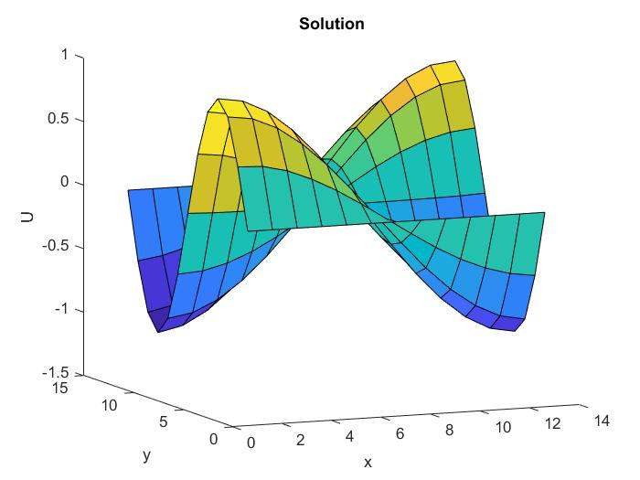

This solution is computed with $N=11⇒h=1/12$. The $L_{2}$-error corresponds to this is equal to $0.0281$. The error is plotted below.

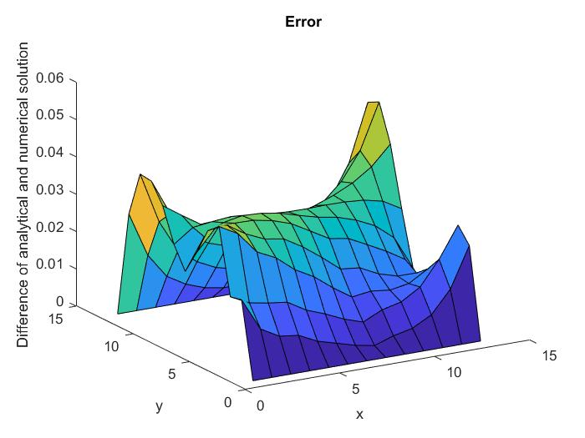

We can see that the error is greatest near $x_{1}=1$.

1. In this problem we change $N$ to $25$. The plots of solution and error are showed below.

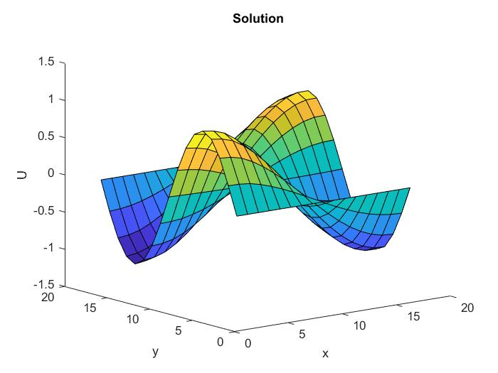

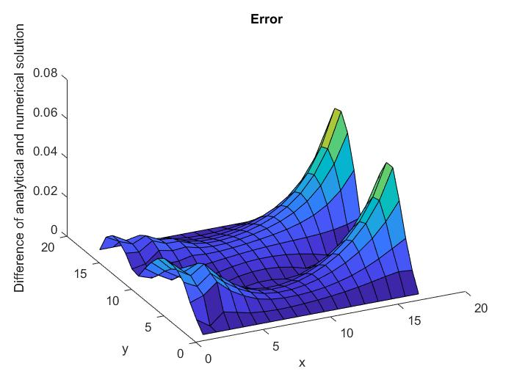

The $L_{2}$– error is then 0.0182 which is smaller than before refinement. However the error is still big near $x_{1}=1$